***Curriculum Vitae***

# PERSONAL INFORMATION

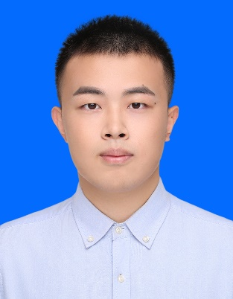**Full Name** Liu Qiyi

**Gender** male

**Date of Birth** 01/12/1997

**Nationality** Chinese

**Address** 66 Changjiang West Street, Qingdao,

Shandong Province,266580, P.R.China

**Telephone** +86-13253253720

**E-mail**  1271359259@qq.com

# EDUCATIONAL BACKGROUN

# Degree Bachelor

# University China University of Petroleum (East China)

# Major Software Engineering

# Start date September, 2016

# Date of graduation June, 2000

# GPA 86.48/100

# Ranking 19/125

# Main Courses Programming Language(C), Advanced Mathematics,

# Essential English, Programming Language (C++),

# Data Structure and Algorithm, Principles of Database,

# Probability Theory &Mathematical Statistics,

# Object-Oriented Programming(Java),

# Object Oriented Analysis and Design,

# Computer Networks, Computer Operating System,

# Computer Principles and Composition

# RESEARCH EXPERIENCE



**Jun 2017 to Jul 2017** QT software training practice: Drawing Software and Notepad

Software

My contribution: as the team leader, assign tasks to team members,

Painting brush function, eraser function, linewidth

function, painting color function, drawing function of

simple geometry, zoom in / out function, project

presentation

**Jun 2018 to Jul 2018**  J2EE software training practice: Personnel Management System

My contribution: as the team leader, assign tasks to team members,

complete database module design, UI design, project

presentation

**Mar 2019 to Jul 2019** Cloud Photo Album

My contribution: UI design(Vue, webpack, Vuex, Vue-router), front-end

and back-end interaction(axios), project presentation.

**Jan 2020 to Jun 2020** undergraduate visiting researcher in the University of Calgary

# STUDENT WORK＆ SOCIAL ACTIVITIES

## 2016 to 2017

**2016 to 2017**

**2017**

**2017 to 2018**

Staff of College Students' Business Activity Center.

Staff of English Early Reading Association.

Volunteer for ACM Competition.

Vice-Minister of College Students Mental Health Association.

# INTERNSHIP

**July, 2017** Computer Basis and Program Design based on C(a student achievement management system)

## July, 2017

**July, 2017**

**July, 2018**

**July,2019**

Knowing practice in Inspur, Hisense.

QT software training practice

J2EE Software Architecture Synthesis Practice

Software Engineering Practice

# ACADEMIC HONORS & AWARDS

## Oct, 2016

**Nov, 2016**

**Dec, 2017**

**Dec, 2017 Nov,2018**

**Oct, 2019**

Excellent cadet in military training

Excellent Organizer in the Second Entrepreneurship Experience Competition.

Outstanding Student of UPC.

Excellent Second Class Learning Scholarship.

Excellent Third Class Learning Scholarship.

Excellent Second Class Learning Scholarship.

# LANGUAGE SKILLS & COMPUTER APPLICATION SKILLS

**Language skills** CET4 (College English Test Grade 4): 546 Dec, 2017

CET6 (College English Test Grade 6): 499 Jun, 2018  IELTS test result, 6.5 Oct, 2018

IELTS test result, 6.5 Nov,2019

**Computer skills** Proficiency in Program Language and software such as C, C++,

JAVA, Webstorm, postman, Pycharm, IntelliJ, MySQL

Master Microsoft Office Software

# SELF-EVALUATION

Self-confidence, Creative, Diligent, Gregarious, Team-Spirited, Responsible.